Introductions/Welcomes
- Introductions –lots of new faces and some familiar faces

Principal Update – Mr. Thompson
- Busy Month
  - Brian Lees Connections
  - Clubs 170 students participating
  - Send issues to Brandy via email
- Questions on Common Core – outside meeting conversation with concerned member
- Summer Reading
  - Always looking for new ways
  - Extend invite to parents for suggestions

Old Business – Treasurer’s Report
- Treasurers Report
      - See Attached

Events – Updates – General Info
- Sept Book Fair Recap
- $3,000 in 90 minutes translates to $1500 scholastic dollars to the school
- After School Enrichment Recap
- 170 students participating
- Going well being handle by Brandy
- Membership drive update
- 73 Members
- The following students have won an extra recess from the PTA Membership Drive. Could you please make sure they get to do this?
- 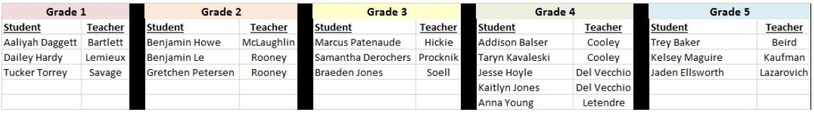
- Here are the winning classes for each grade. Grades 1, 2, 3 & 5 winning classes will receive (5) Burkland’s Best tickets for each student. (PTA will send that out) Del Vecchio’s Grade 4 class is the big winner and will get the (5) Burkland’s Best tickets and the Popsicle party. Just let me know how we should work the Popsicle party.
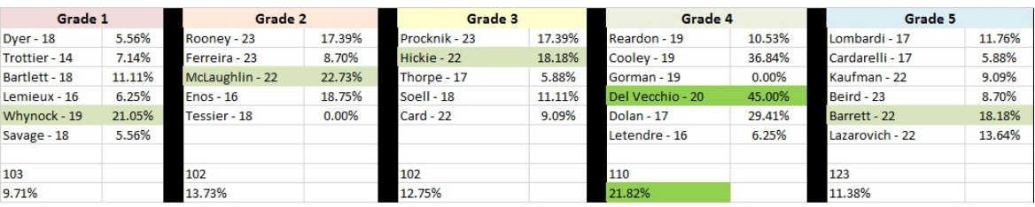
- Hat day recap
- $145 collected and donated to Jesse Heckler Foundation
- HBB@HBB
- 2 ½ hour
- Ready to go
- Early Setup if possible
- Pie Sales
- Flyers sent due 10/15/2018
- Pick up 11/9/2018

Committee Updates
- Husky Haven
  - School Store Explained
  - Needed some spirt wear Jen okayed

- Box Tops – Due 10/15/18
- Spirit Wear 1st Order sent for Volunteers

New Business
- Spaghetti Supper
  - Looking for new Food Sponsor MaMa Mia has backed out
- Holiday Shoppe?? (separate or with Book fair)
  - 12/5/18 During the day
- NMS PTA meeting tomorrow night - 7pm at NMS library
- Artsonia
  - Information to be sent home
- Field trips - 4th Grade
  - Donovan Llyod Center Dartmouth MA – Salt Marsh/LABS
- MCAS – going home Friday 10/12/2018
- Suggestion Game Show Night – Adults – Family Trivia Nights

Next Meeting – November 13th in HBB - Library

